**Supplementary Table 1. List of highly conserved miR-29 target genes that are upregulated by LNA29.** The conservation of miR-29 target genes is determined by the presence of at least one predicted target site that is positionally preserved in two additional species besides mouse.

|  |  |  |  |  |  |
| --- | --- | --- | --- | --- | --- |
| PHC1 | LRP6 | PLEKHA8 | TMEM136 | EMP2 | CCNJ |
| BDH1 | TMEM86A | ZBTB5 | FBXW9 | TFEB | ABCB6 |
| EDC3 | CTNNBIP1 | SCAMP5 | PPIC | UNC13B | COL5A3 |
| AQP4 | SPNS1 | MSTO1 | CLDN1 | SESTD1 | OSTC |
| ENPP2 | COL4A1 | GAS7 | COL3A1 | RAB12 | C1QTNF6 |
| TMEM229B | DGKD | FBXL18 | KLHDC3 | DIP2C | UBN1 |
| TMEM164 | SPRN | ZBTB10 | MARVELD1 | VPS25 | HSPG2 |
| MXD4 | BBC3 | AGPAT5 | TPM1 | WISP1 | ENHO |
| SERPINH1 | AFAP1L1 | CBX1 | OTUB2 | FOXO4 | FAM136A |
| KDM5C | EIF4E2 | SNRPC | GOLGA7 | SLC16A1 | COL1A1 |
| PHLDB3 | IREB2 | ARF5 | UBTF | NASP | CCDC28B |
| SGK1 | RNPEPL1 | CYTH3 | SPPL2B | PDGFA | FBN1 |
| FAM13B | CANX | LAMTOR1 | TRIB3 | DIABLO | ING4 |
| FSTL1 | DOT1L | MORF4L1 | ATG9A | DTX4 | IFI30 |
| VPS36 | TRAM2 | DNMT3B | KCTD3 | ELF2 | SPATA2L |
| LPL | TDG | BCL2L2 | BSDC1 | CALM3 | BAK1 |
| JOSD1 | COL4A5 | CDK6 | ADAMTS7 | LAMC1 | ERP44 |
| DCP2 | COL4A2 | TUBB2A | FEM1B | TSPAN14 | CENPB |
| RCC2 | PAN2 | SH3BP5L | MTX3 | EFNA5 | MAP4K4 |
| GPX7 | AMMECR1 | MFAP3 | EPHA1 | UBE2Q1 | VAMP3 |
| DPP4 | CHFR | RRAS2 | COL15A1 | ELN | BLMH |
| MORF4L2 | LOXL4 | DNMT3A | FERMT2 | SLC35B2 |  |
| NKIRAS2 | SMPD3 | RNF138 | DOLPP1 | YPEL2 |  |
| KDM4A | PPL | SPARC | MAZ | DUSP22 |  |
| GCNT2 | EIF4H | RAB30 | ZBTB34 | SETD7 |  |
| PLXNA1 | PXDN | MCL1 | KDM5B | KDELC1 |  |
| ERLIN2 | STRN4 | LYSMD1 | NDST1 | BACE1 |  |
| FAM134C | KDM6B | LTBR | MMP2 | BRD3 |  |
| SLC16A2 | ZFP91 | SPTLC2 | TET3 | SNX24 |  |
| COL5A2 | SIKE1 | SOX12 | SPAST | SAP30L |  |



**Supplementary Figure 1. PCA plots of hepatic miRNA profiles in the liver of rodent IR models.** **a**, PCA plot of miRNA profiles from small RNA-seq (smRNA-seq) data from the liver of *ob/ob* mice and lean controls.  **b**, PCA plot of miRNA profiles from smRNA-seq data from the liver of STZ-injected mice and saline controls.  **c,** PCA plot of miRNA profiles from smRNA-seq data from the liver of ZF rat and lean controls. *Ob/ob* mice n=5 (control n=5), STZ mice n=5 (control n= 5), ZF rat n=5 (control n=5).



**Supplementary Figure 2. Therapeutic interventions for diabetes attenuate miR-29b levels in both rodent and non-human primate models. a**,PCA plot of miRNA profiles from smRNA-seq data from the liver of ZF rats with BT2 or vehicle treatment. **b**, Volcano plots of differentially expressed miRNAs in BT2-treated rats compared to vehicle-treated rats (log2 fold change cutoff = 0.5). **c**, Sequencing data of miR-29b expression in BT2- and vehicle-treated rats. **d**, Venn diagram identifying the miRNAs that are both upregulated in ZF compared to lean control rats and downregulated in BT2-treated compared to vehicle-treated rats by log2 fold change cutoff of 0.5. The identified miRNAs are listed in the small table to the right of the Venn diagram. **e**, PCA plot of miRNA profiles from smRNA-seq data from the liver of fructose-fed rhesus macaques supplemented with fish oil or sunflower oil (control). **f**, Volcano plots of differentially expressed miRNAs in fructose-fed rhesus macaques supplemented with fish oil compared to sunflower foil control. **g**, Sequencing data of miR-29b expression in fructose-fed rhesus macaques supplemented with fish oil or sunflower oil (control). RPMMM, reads per million mapped to miRNAs. BT2-treated ZF rat n=5, vehicle-treated ZF rat n=5, fish oil-treated monkey n = 3, sunflower oil treated monkey n = 3.

b

c

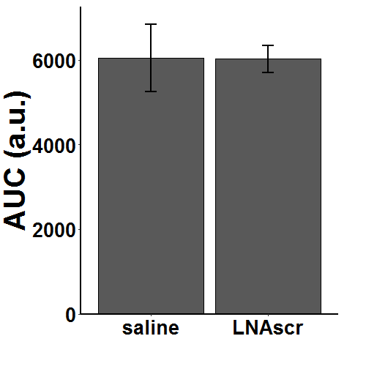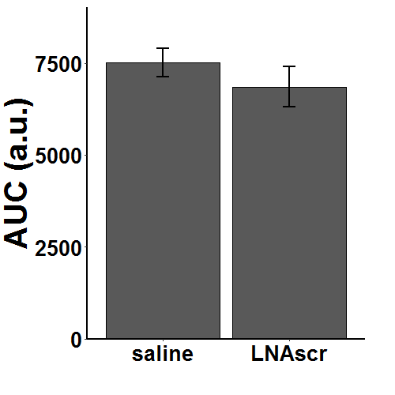

e

f

a

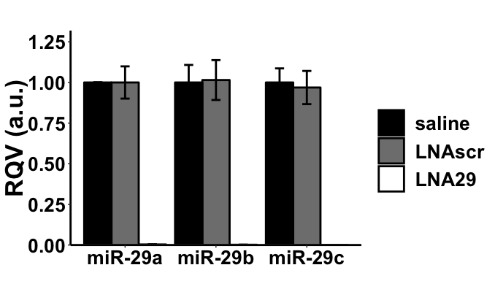

***

***

***

d

**Supplementary Figure 3. *In vivo* study assessing the impact of LNA29 on glycemic control in chow-diet fed lean C57BL/6J mice. a**, RT-qPCR of hepatic miR-29 familyof chow-fed mice in the indicated treatment group (saline, n=2, LNAscr, n=6; LNA29, n=5). LNA29 leads to 269, 237, 3242 folds suppression in miR-29a, b and c, respectively (compared to LNAscr treatment). * P < 0.05, ** P < 0.01, *** P < 0.001 by two-tailed Student’s t-test between LNA29 LNAscr treatment. **b**, Blood glucose of overnight fasted mice treated with either LNAscr or saline. **c**, Area under curve (AUC) of blood glucose curves determined in OGTT in mice treated with LNAscr or saline. **d**, AUC of blood glucose curves determined in IST in mice treated with LNAscr or saline. **e**, Body weight of mice treated with either saline or LNAscr at day 8 post-dosage. **f**, Body weight of mice treated with either saline or LNA29 at day 8 post-dosage. n=5-6 per group for each experiment/measurement.



**Supplementary Figure 4.  *In vivo* study assessing the impact of LNA29 on glycemic control in HFD-diet fed obese C57BL/6J mice. a,** Body weight of mice fed with 4 weeks of HFD compared to aged matched chow mice (HFD, n=6; chow, n=4). **b,** Levels of blood glucose of HFD- and chow-fed mice during the time course of OGTT (HFD, n=6; chow, n=4). **c**, Area under curve (AUC) calculated from the OGTT shown in (b). **d,** Levels of blood glucose of HFD- and chow-fed mice during the time course of IST (HFD, n=6; chow, n=4). **e**, AUC calculated from the IST shown in (d). **f**, Pre-dose overnight fasting glucose of HFD-fed mice assigned to either LNAscr or LNA29 treatment (LNAscr, n=3; LNA29, n=3). **g**, RT-qPCR of hepatic miR-29 familyof HFD-fed mice in the indicated treatment group (LNAscr, n=3; LNA29, n=3). LNA29 leads to 699, 387, 1741 fold suppression in miR-29a, b and c, respectively. **h**,qPCR of Co1a1, a validated miR-29 target gene,of HFD-fed mice in the indicated treatment group (LNAscr, n=3; LNA29, n=3). **i**, AUC calculated from the OGTT test of HFD-fed mice in the indicated treatment group (LNAscr, n=3; LNA29, n=3). **j**, AUC calculated from the IST test of HFD-fed mice in the indicated treatment group (LNAscr, n=3; LNA29, n=3). * P < 0.05, ** P < 0.01, *** P < 0.001 by two-tailed Student’s t-test.

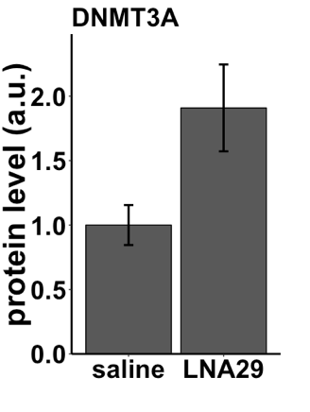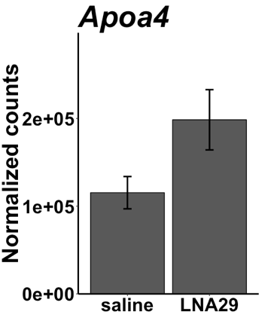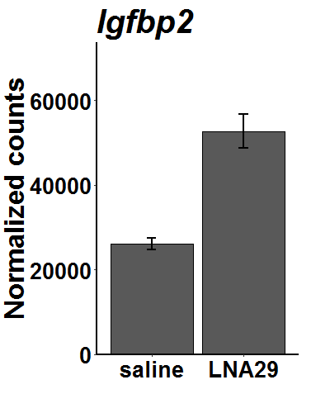

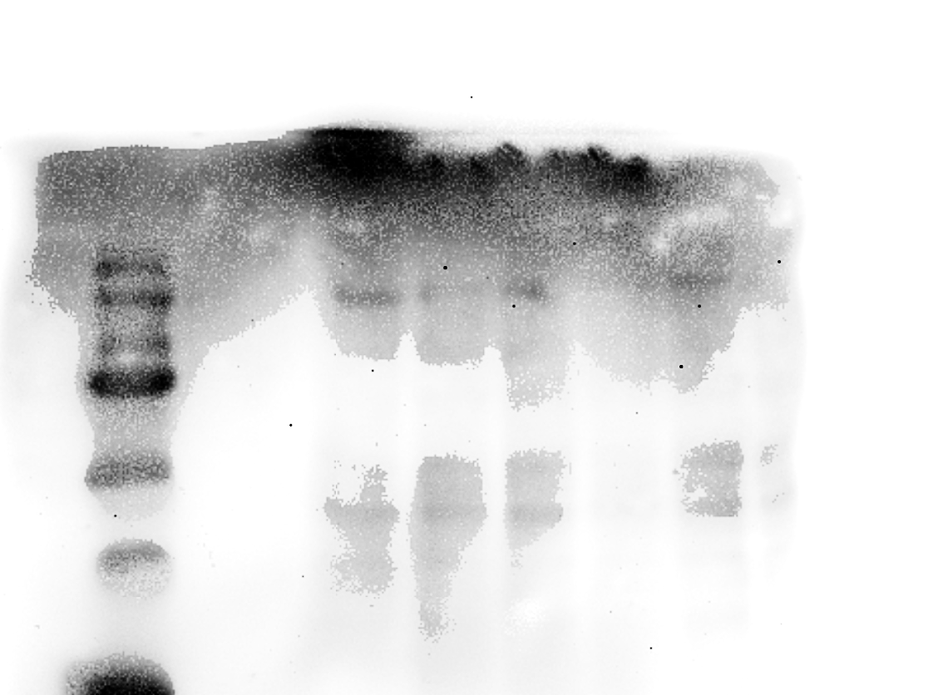

DNMT3A

GAPDH

LNA29

saline

150 kb -

**\***

**\*\*\***

d

c

b

a

**\***

**Supplementary Figure 5. Genes which are upregulated in the liver of chow-fed mice treated with LNA29 compared with saline.** (a)Protein quantification of DNMT3A in mouse fasted liver by western blotting. Western blot densitometry is normalized to GAPDH. Saline, n=3; LNA29, n=3. * P < 0.05 by one-tailed Student’s t test. (b) Representative western blot image of DNMT3A. (c) RNA-seq expressed levels of *Igfbp2* in mouse fasted liver in the indicated groups. Saline n=6, LNA29 n=5. *** P < 0.001 by Wald test (DESeq2). (d) RNA-seq expressed levels of *Apoa4* in mouse fasted liver in the indicated groups. Saline n=6, LNA29 n=5. * P < 0.05 by Wald test (DESeq2).